**President Truman declares the end of World War 2.**

**USS Indianapolis departs San Francisco with top secret cargo of carefully packed uranium-235- the integral components of the atomic bomb known as “little boy”.**

*USS Indianapolis Timeline of 1945*

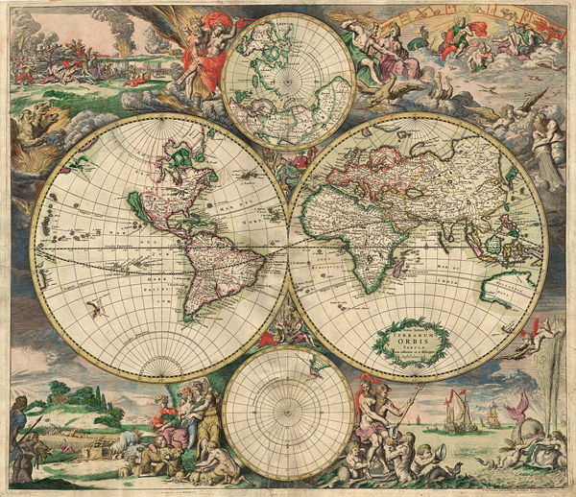

**The atomic bomb “little boy” is dropped on Hiroshima.**

**The last of the survivors are pulled from the ocean after nearly five days in the shark-infested waters.**

**By the third day in the water with little to no food or water, thirst leads many to drink sea water. Delirium and hallucinations make conditions even more treacherous for the survivors. The sharks continue their frenzied attacks.**

**USS Indianapolis is hit by two Japanese torpedoes from an I-58 submarine at 12:05 A.M. The vessel sinks in 12 minutes, yet approximately 900 men abandon ship. Nearly 300 men go down with the ship.**

**USS Indianapolis departs Guam for Leyte, 1,300 miles west, in preparation for the invasion of Japan.**

**By the second day of being afloat, many survivors have already died of wounds inflicted from the blast.**

**Navy pilot Chuck Gwinn, out on a routine sub-hunting patrol, accidently spot the oil slick, then one of the groups of survivors. One of World War 2’s largest sea rescue missions begin.**

**The Atomic bomb is delivered safely to Tinian Island, near Guam in the Philippine Sea, in record time.**

|  |  |  |  |  |  |  |  |
| --- | --- | --- | --- | --- | --- | --- | --- |
| July 16 | July 26 | July 28 | July 30 | July 31 | August 1 | August 2 | August 3 August 6 August 14 |