[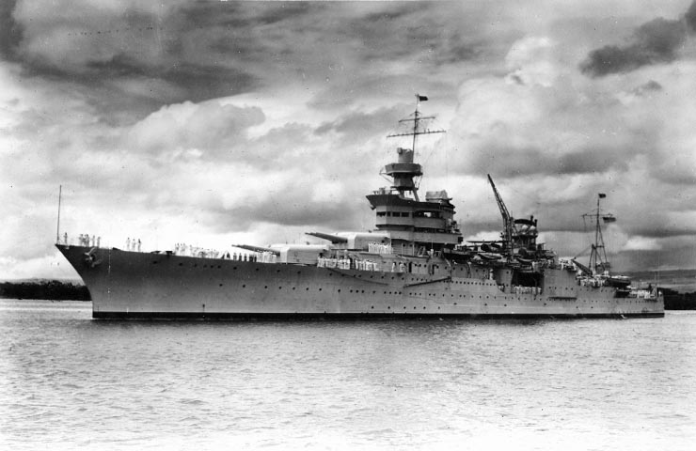](http://upload.wikimedia.org/wikipedia/commons/1/1a/USS_Indianapolis_CA-35.jpg)

USS Indianapolis CA-35